Create two VPC's in different regions andconnect the two vpc's

**1: create a vpc in one region : n.virginia**

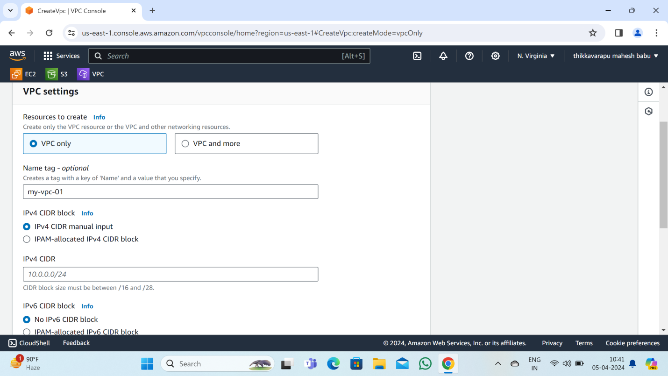

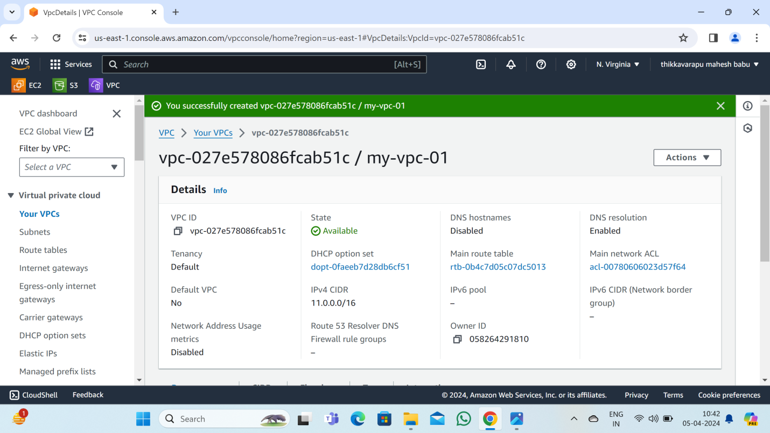

**2: create a subnet:**

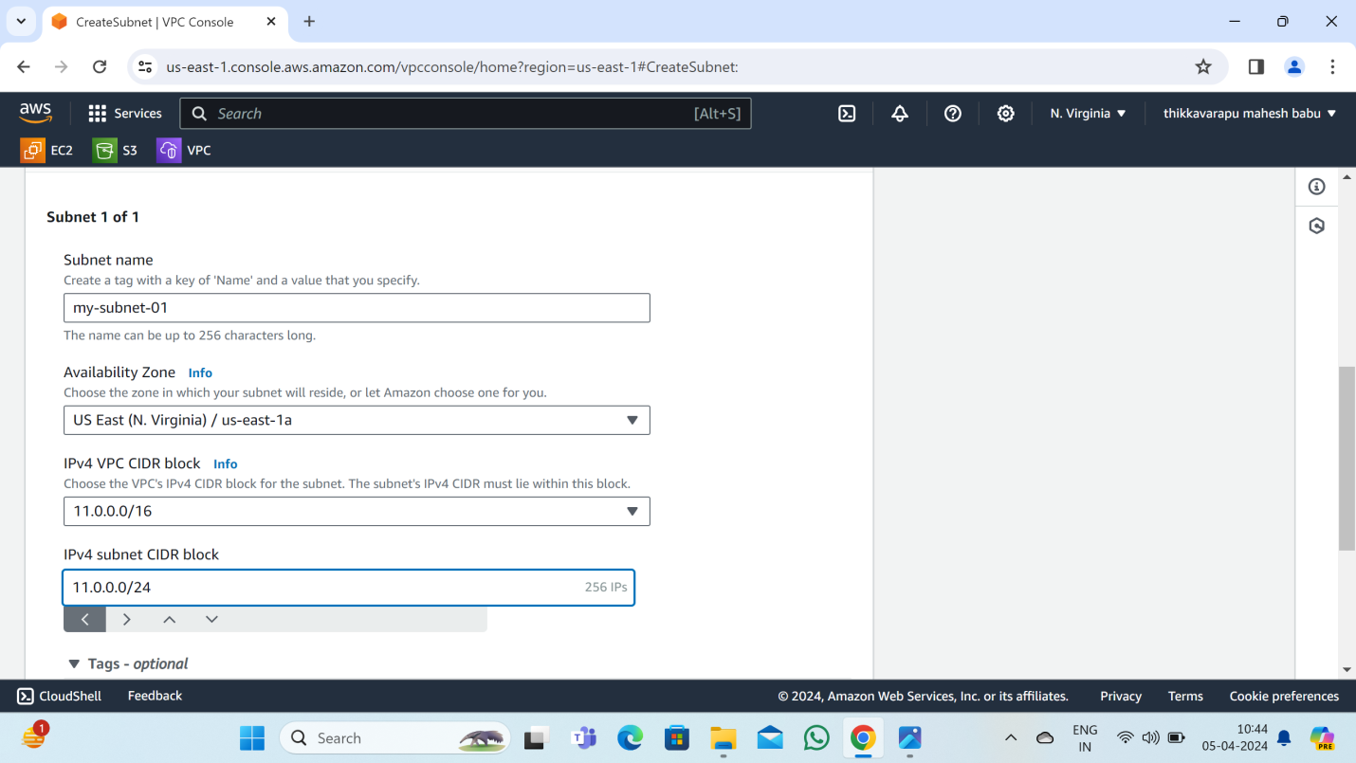

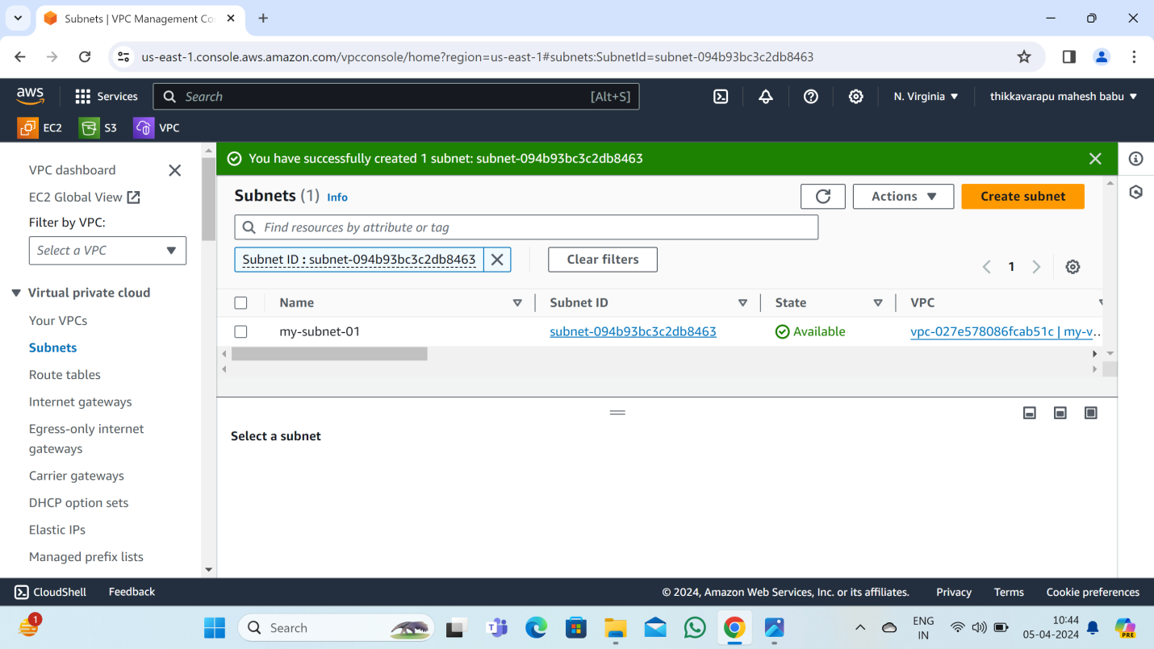

**3: create internetgateway:**

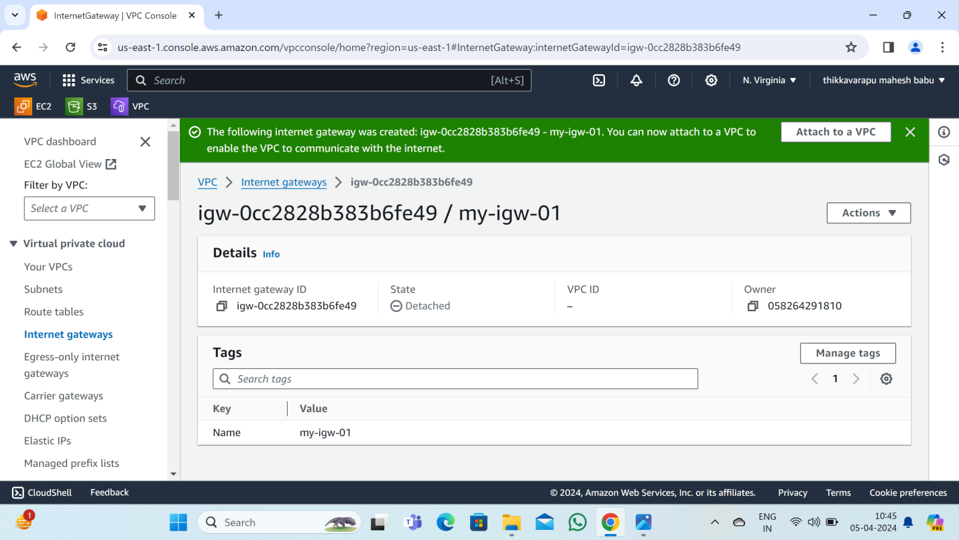

**: Attach to a vpc in internet gateway:**

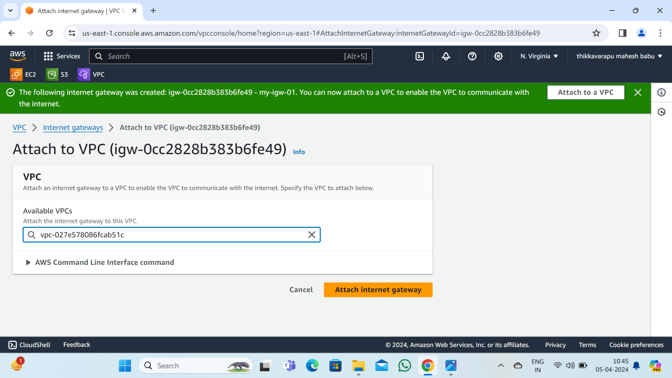

**4: create a route table:**

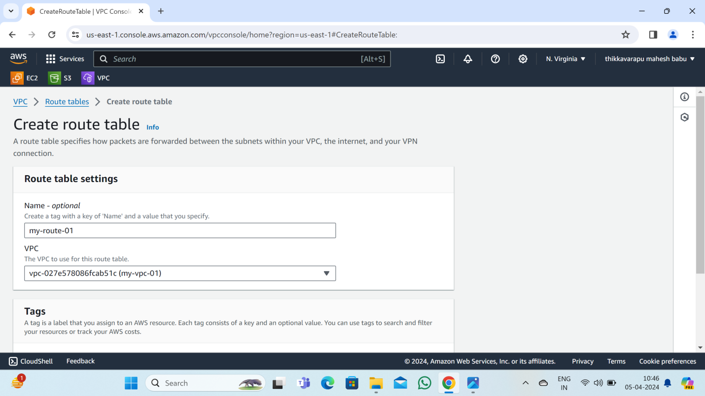

**: Edit subnet association :**

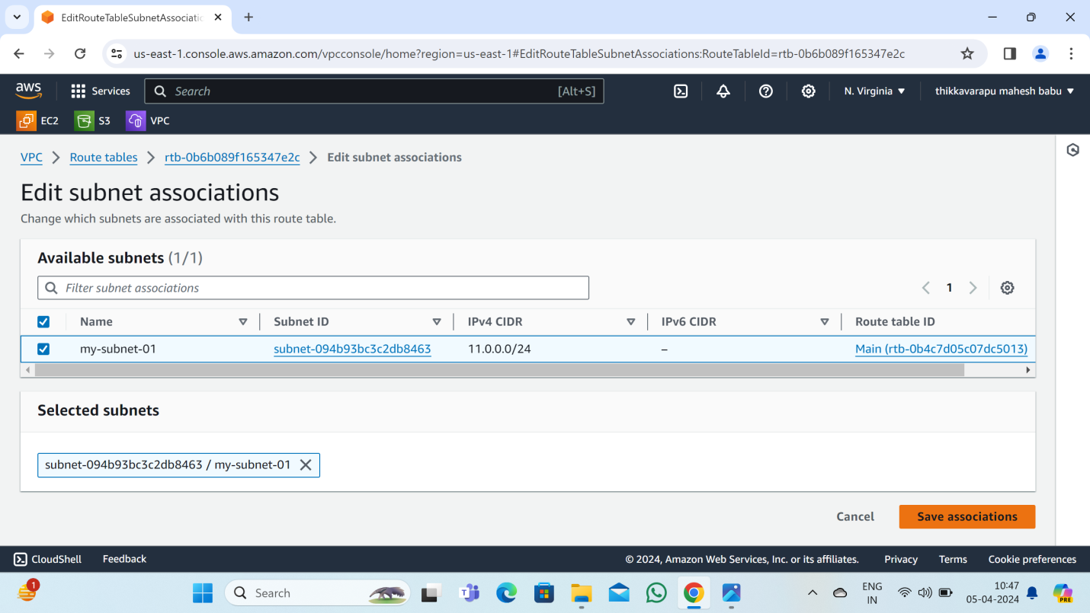

**: Edit routes: click add routes :**

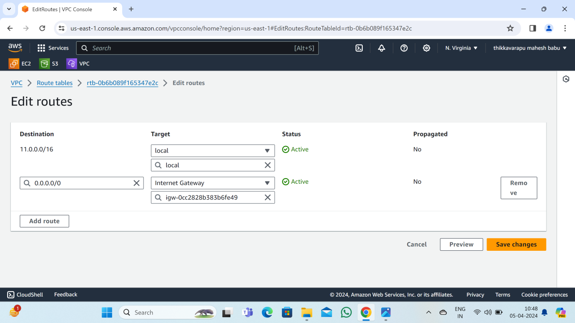

**5: create EC2 instances:**

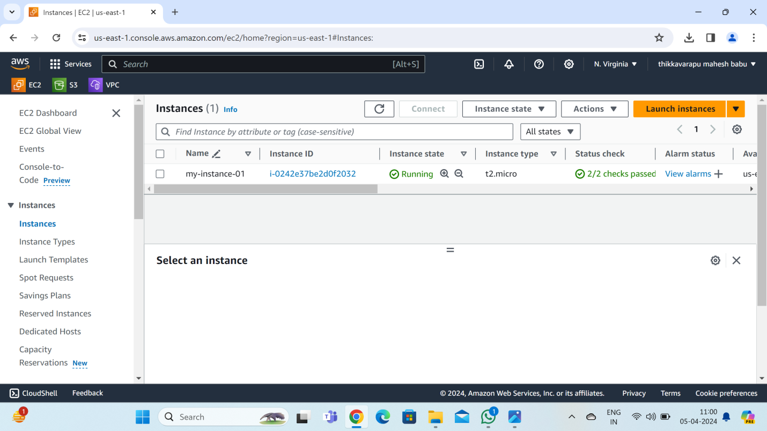

**: connect to the server:**

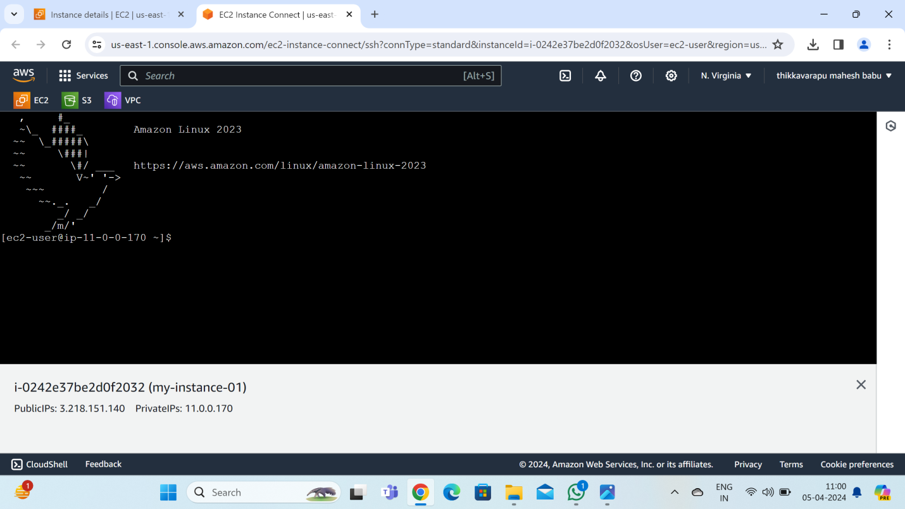

**Same process:**

**1: create a vpc in another region: singapore**

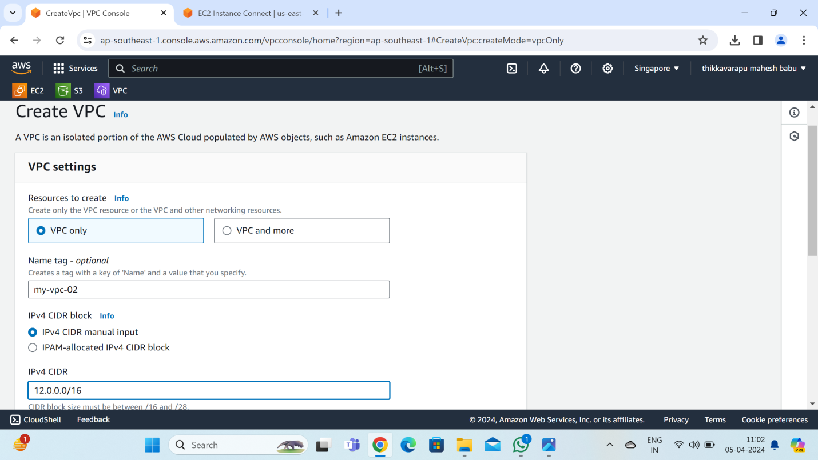

**2: create a subnet:**

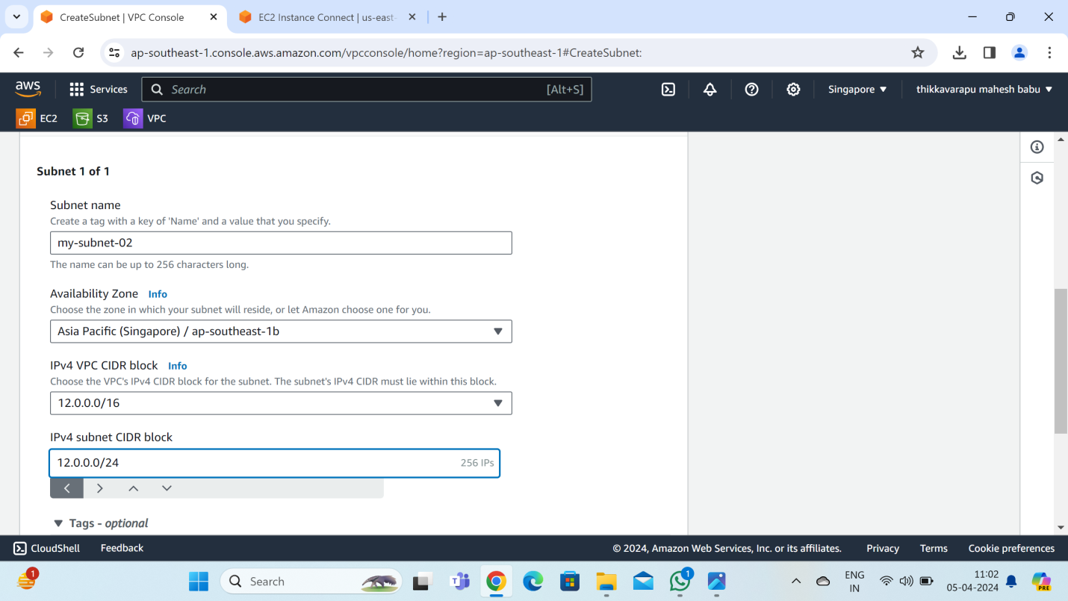

**3: create internet gateway:**

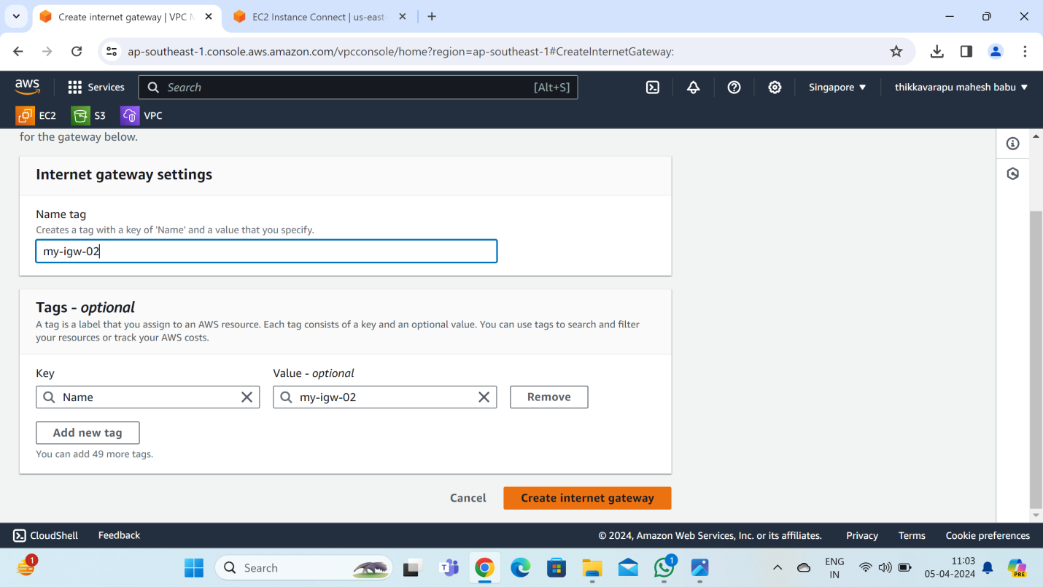

**Attach to a vpc in internet gateway:**

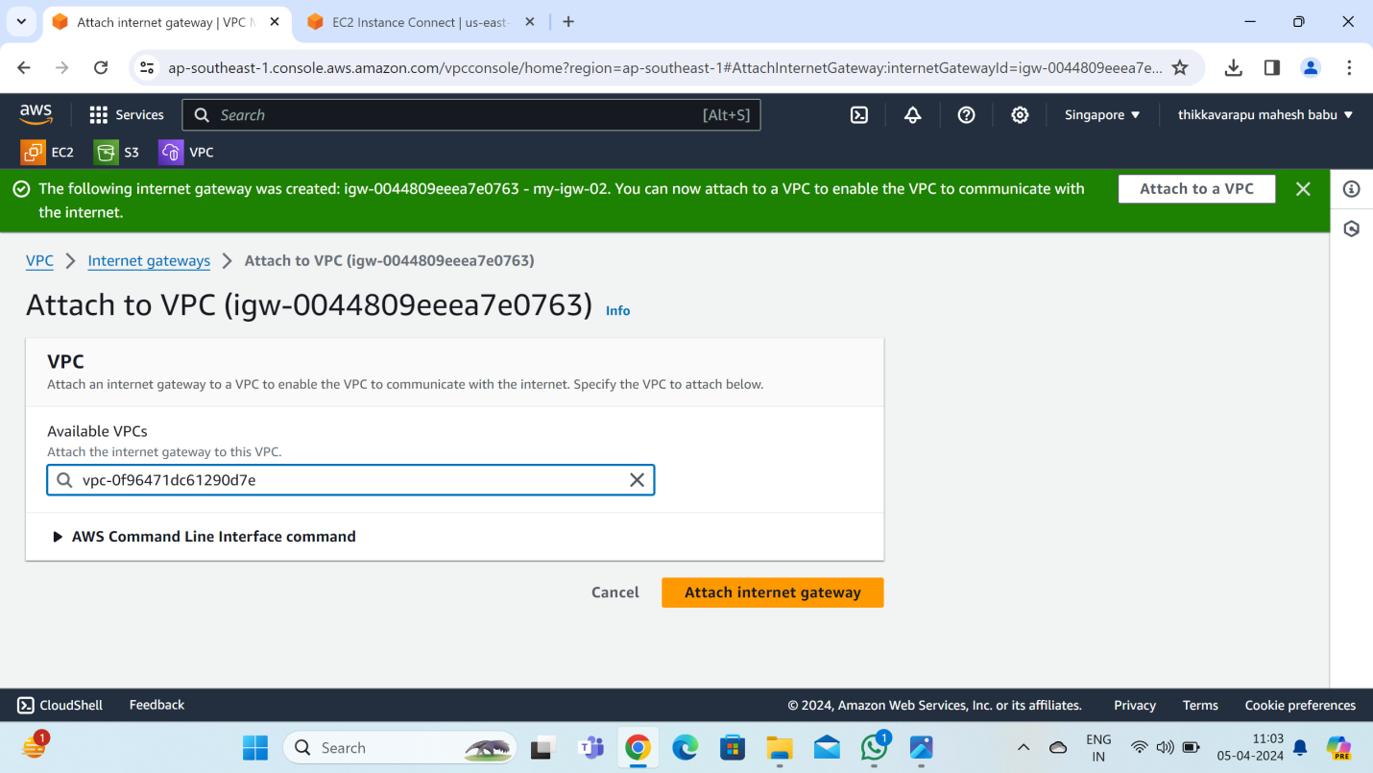

**3: create a route table:**

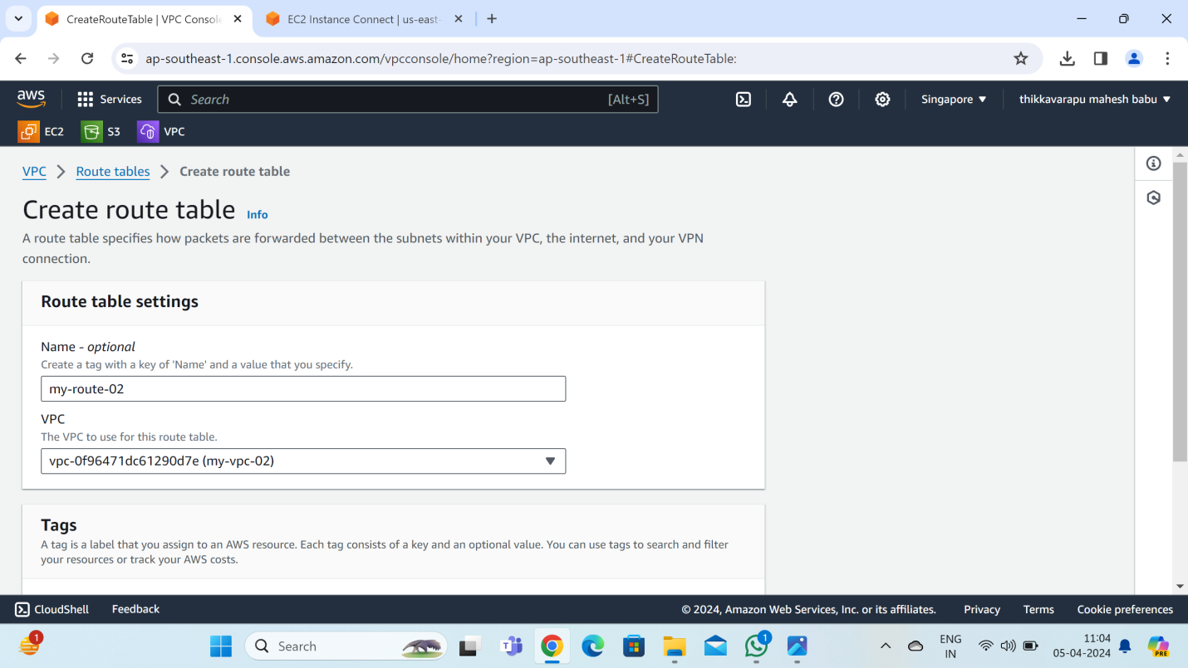

**Edit subnet association :**

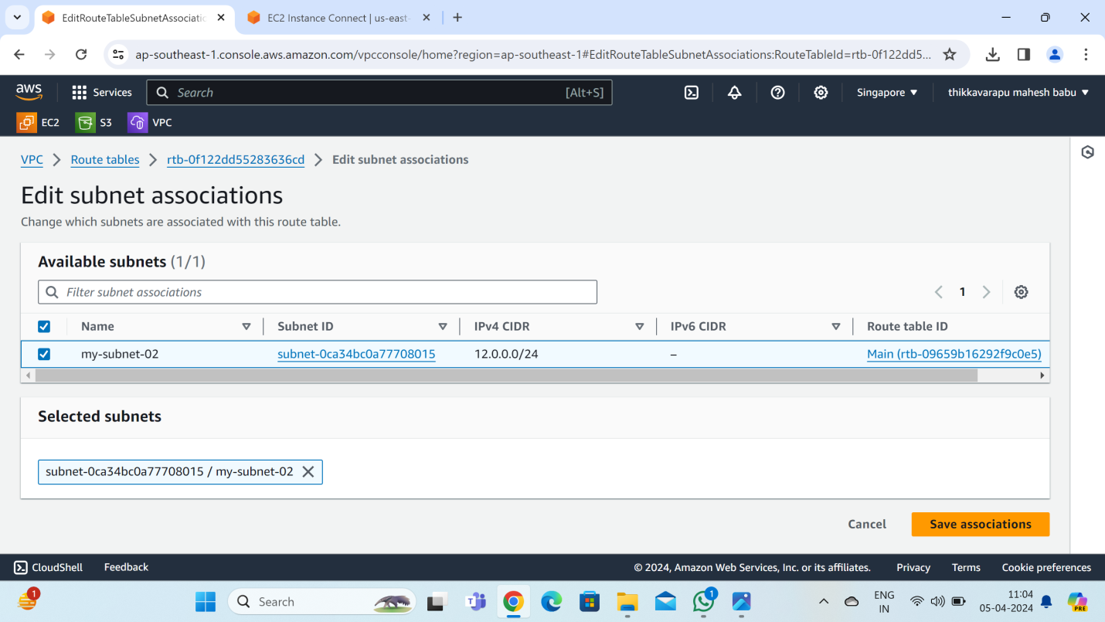

**Edit routes: add routes:**

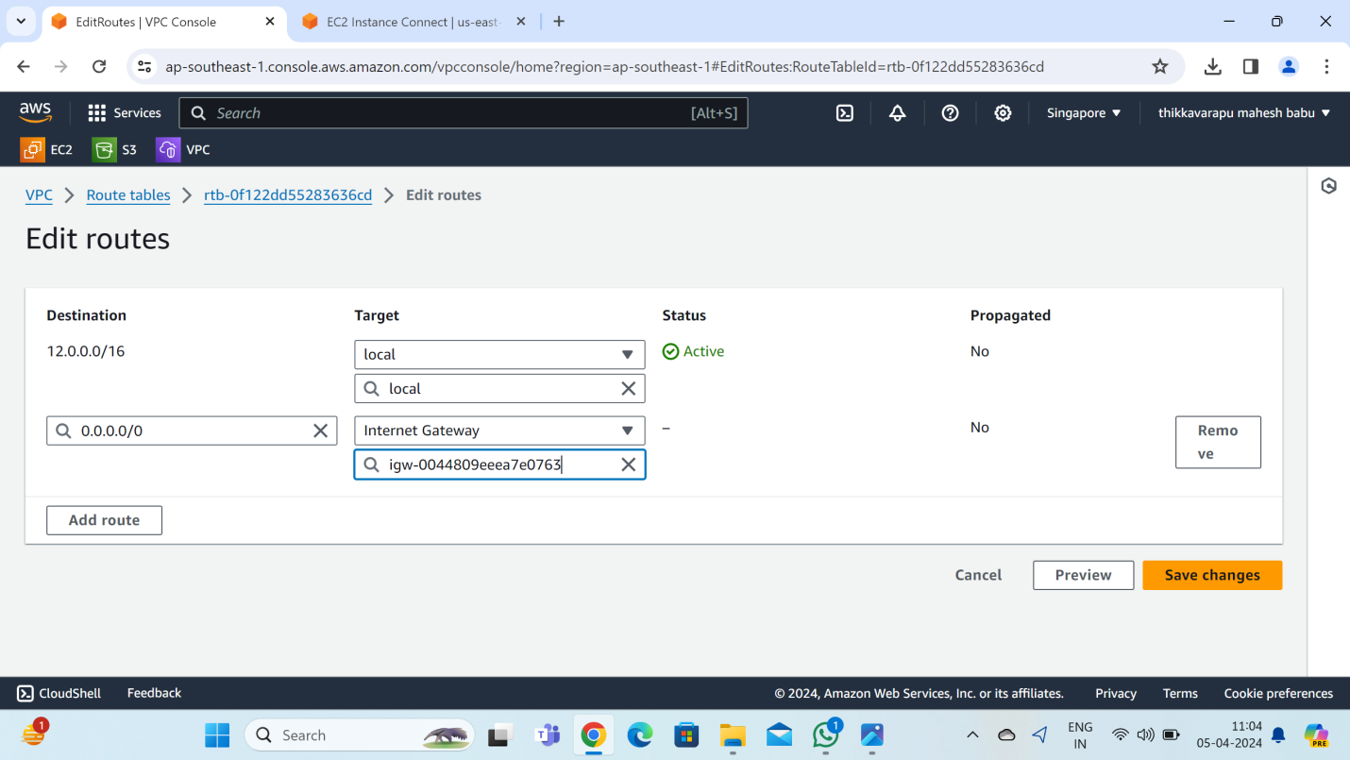

**5: create a EC2 instances:**

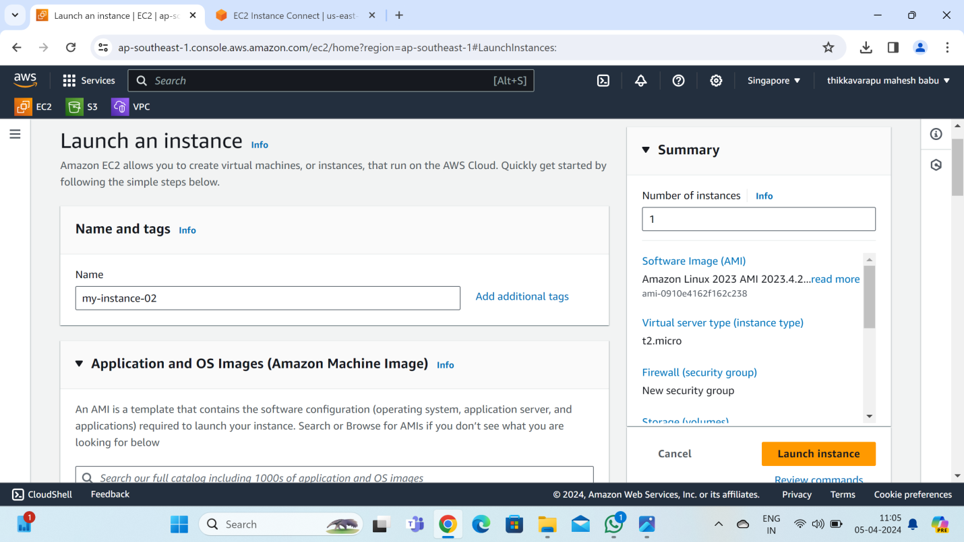

**Create a new key pair:**

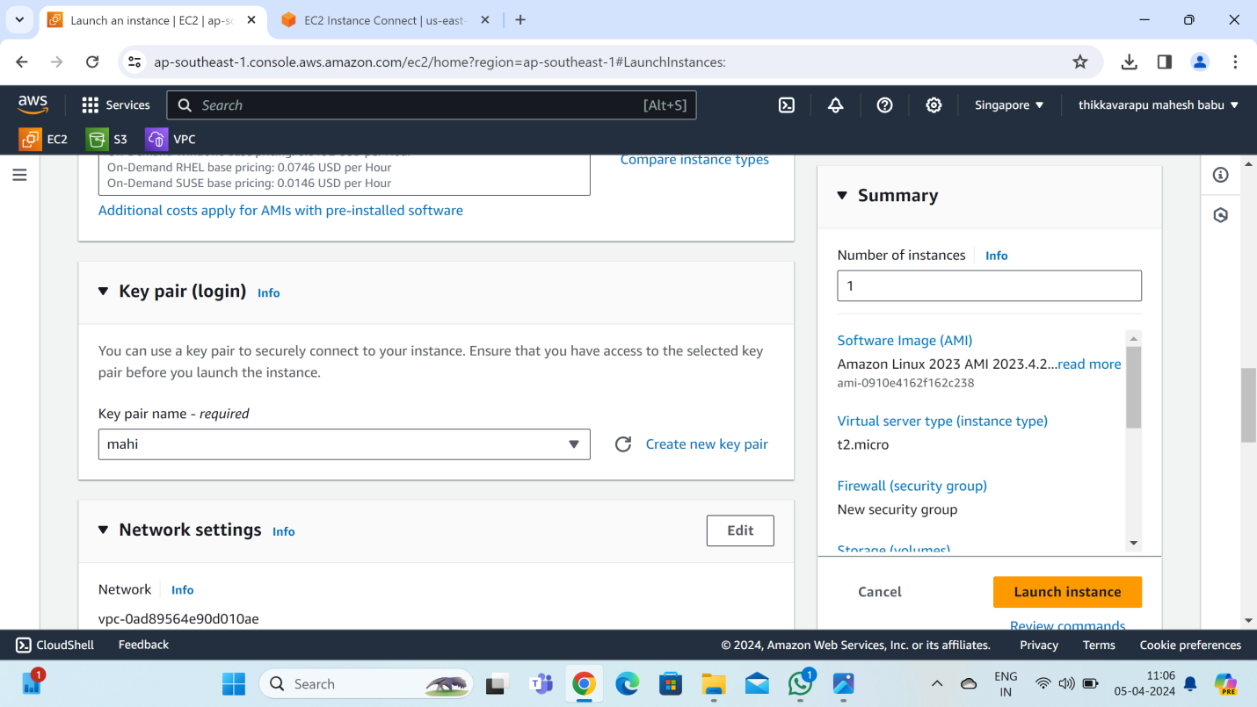

**Edit security group rules: “click” add security group rules:**

**Type:HTTP,source:0.0.0.0/0**

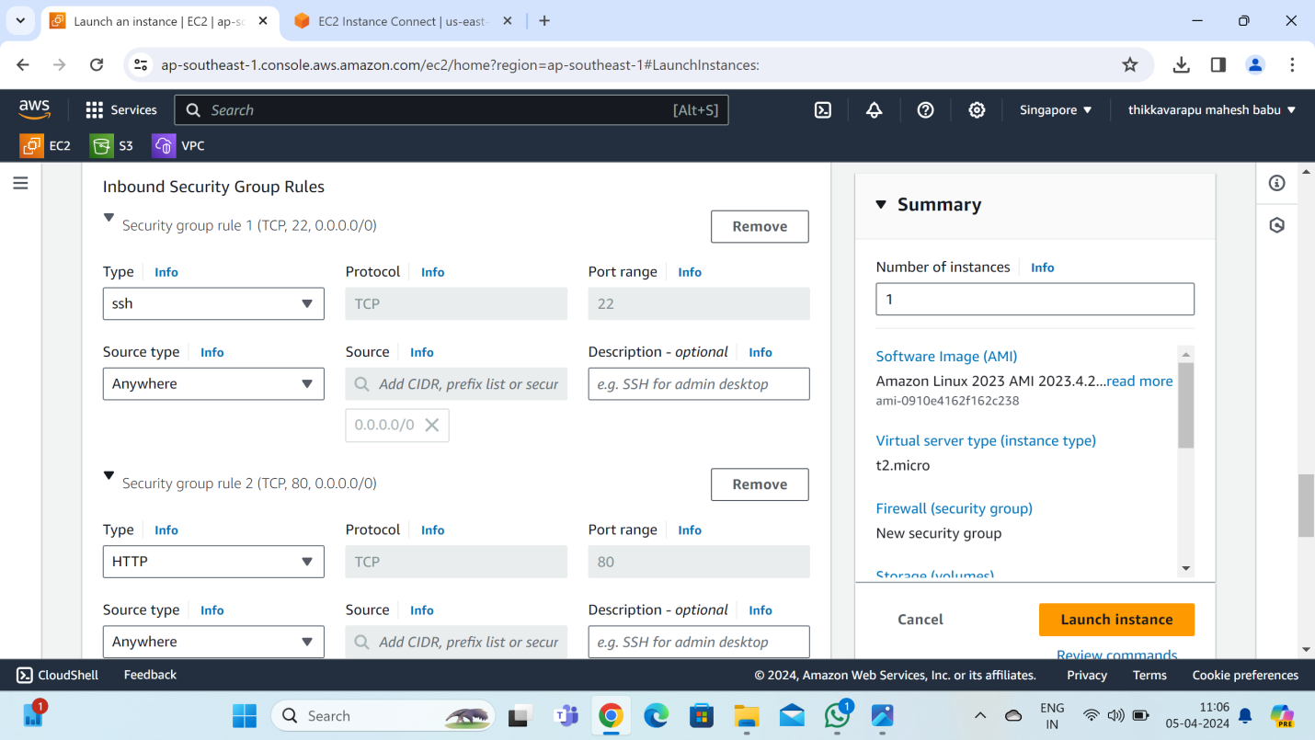

**Choose file:**

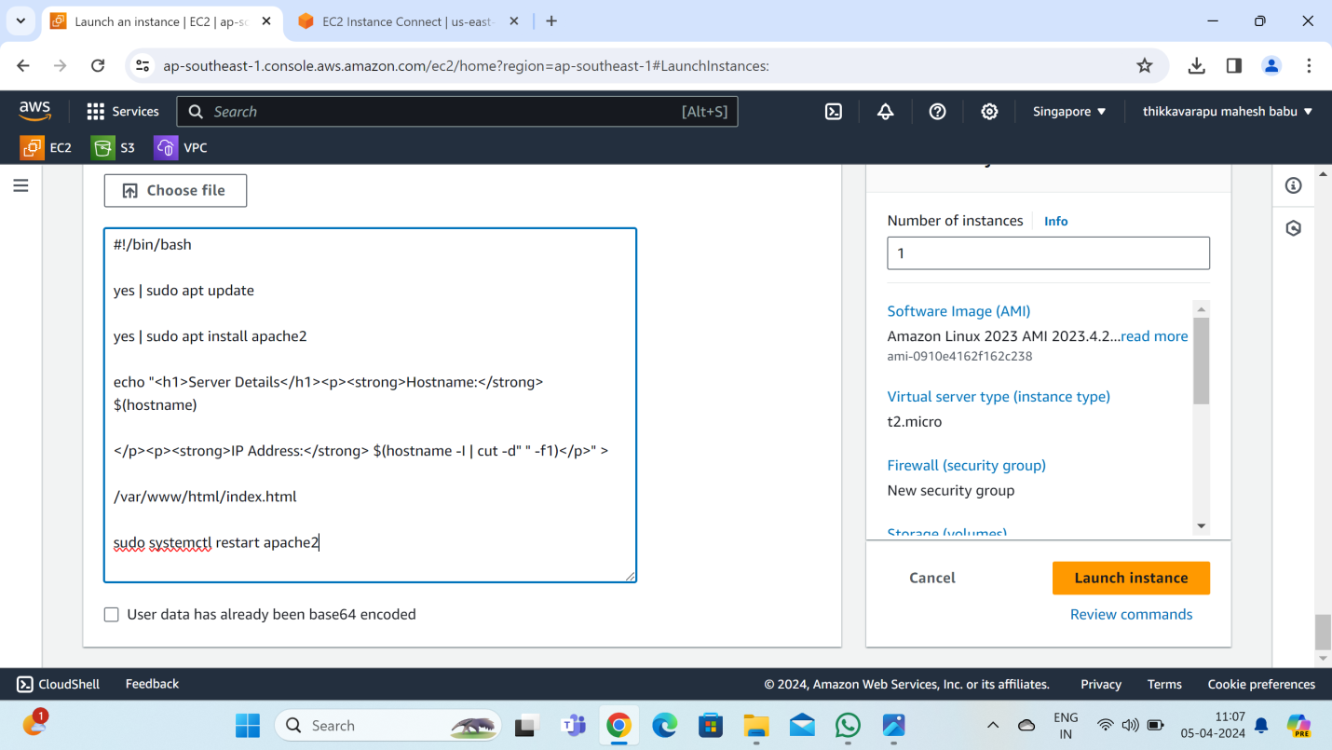

**Connet to the server:**

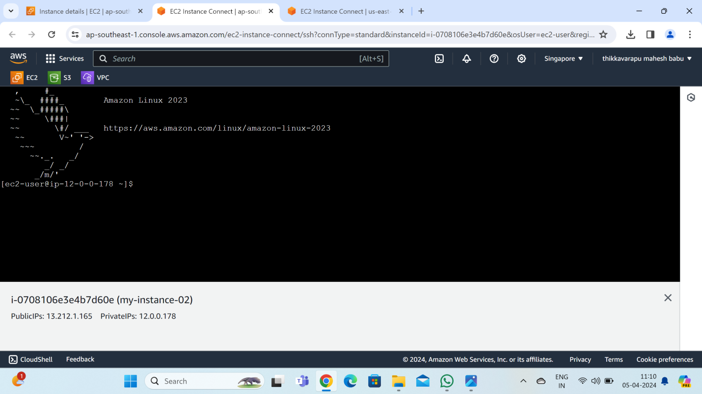

**Create a peering connection:**

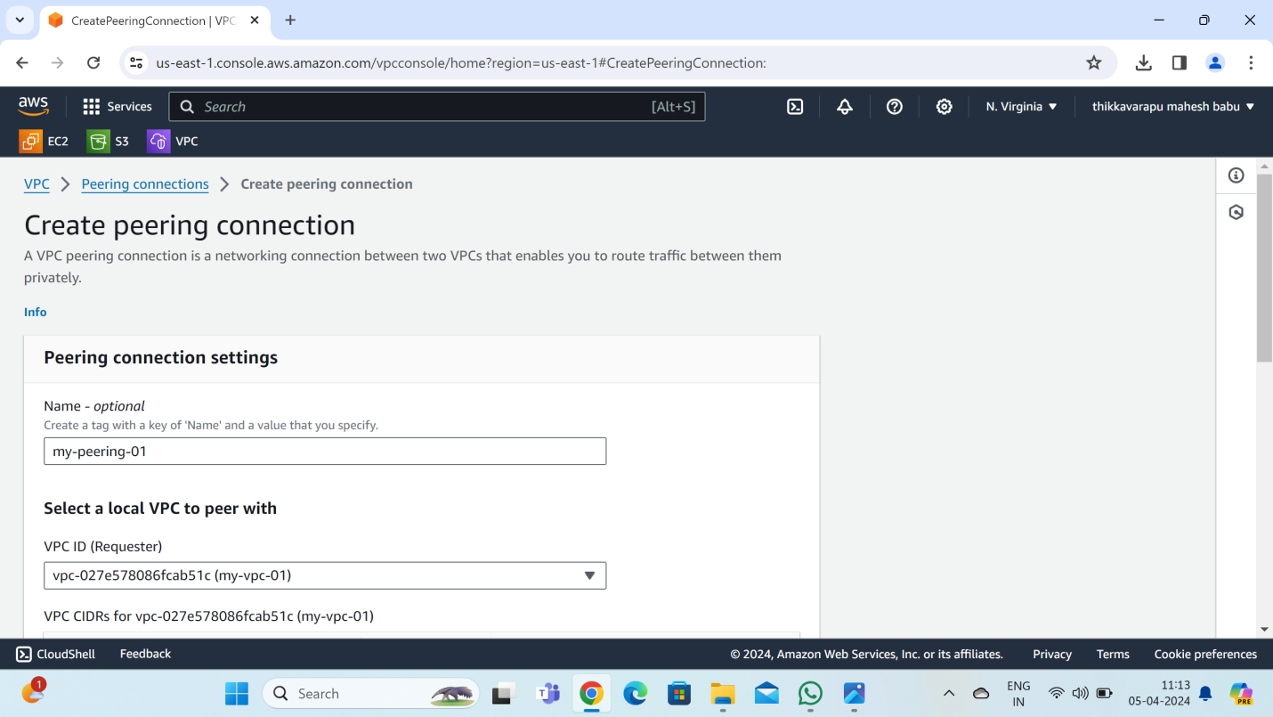

**Account : my account**

**Region :this region**

**Vpc ID(accepter): singapore region vpc**

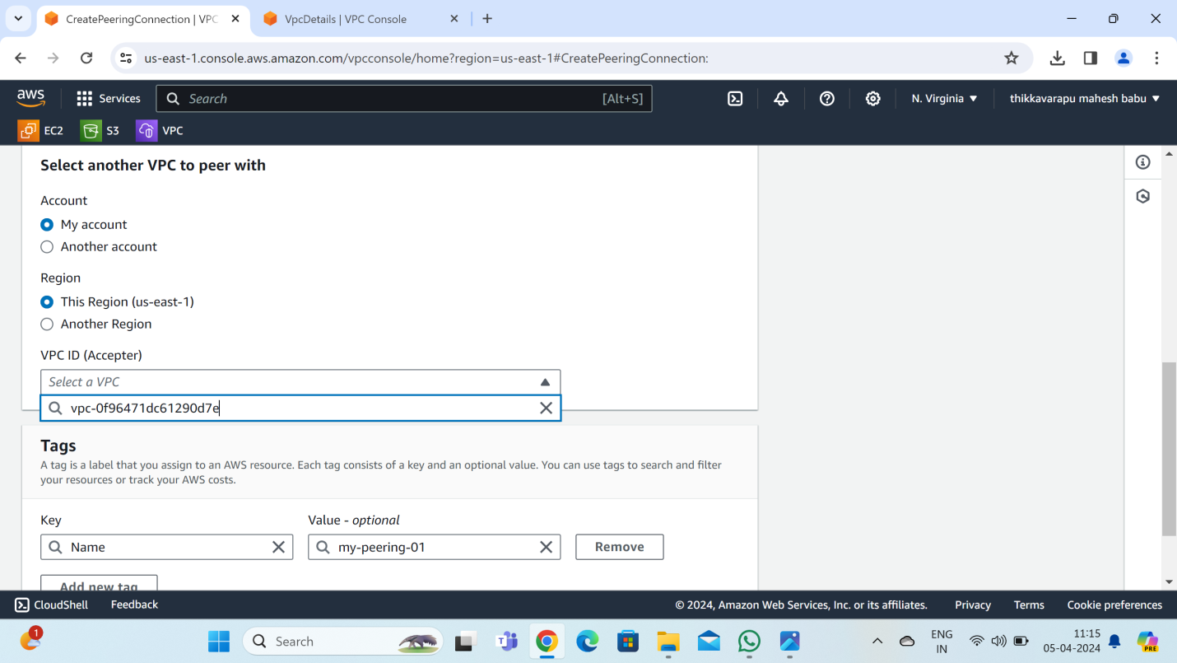

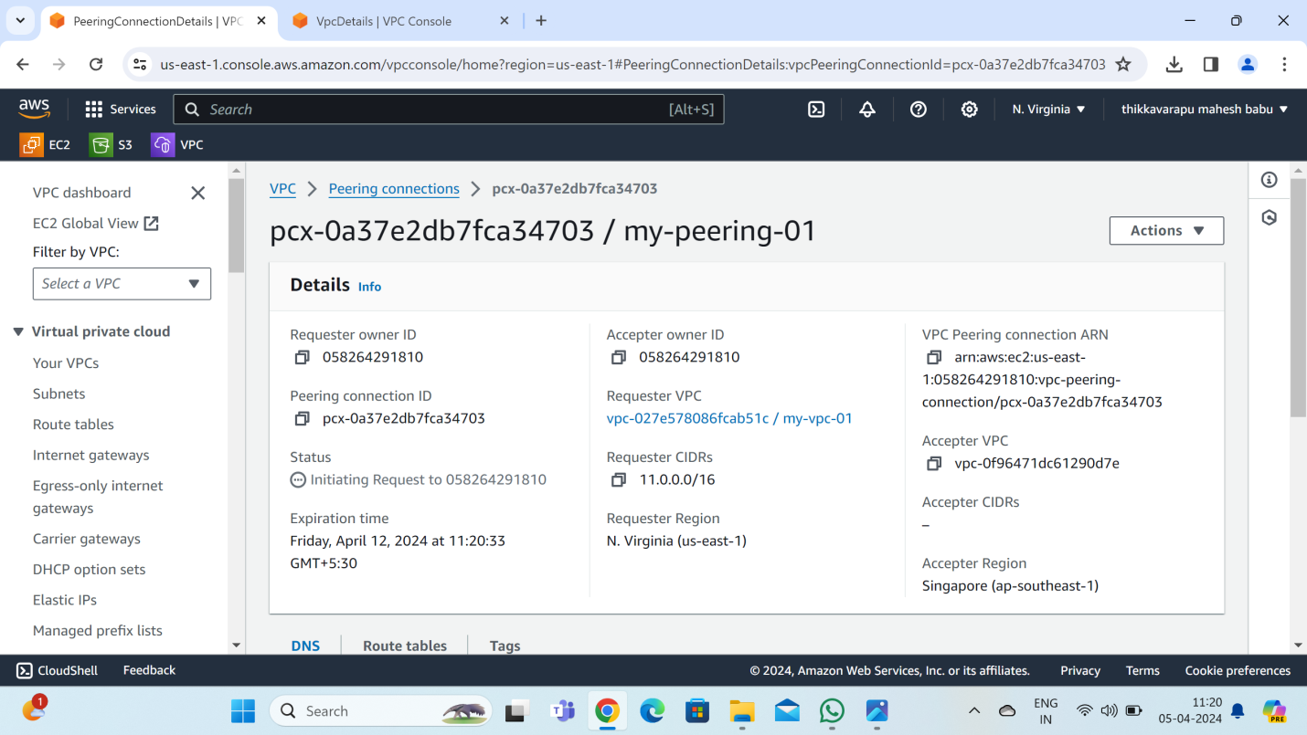

**In Singapore region :accept request**

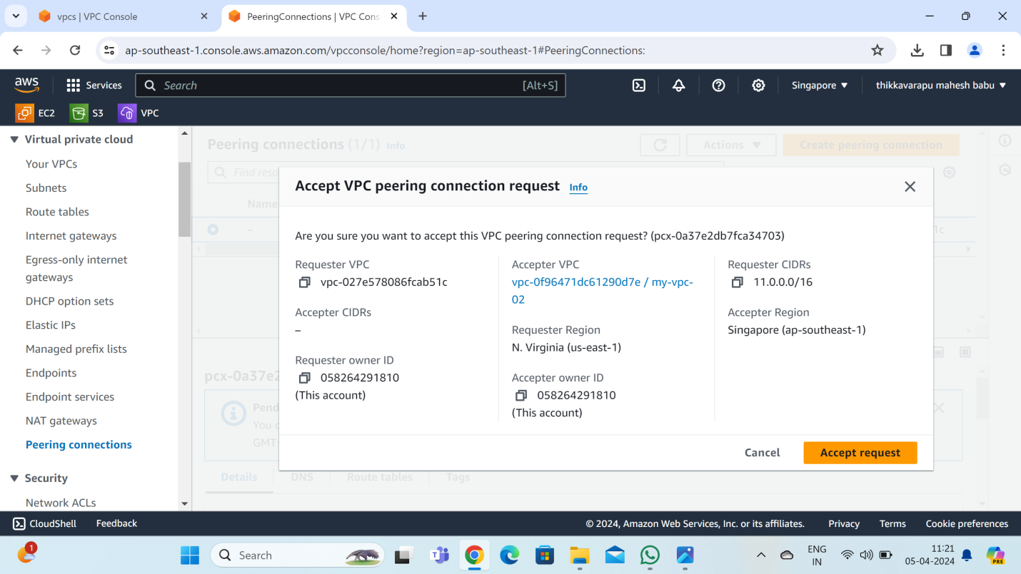

**Go with route table :**

**edit routes:**

**Add routes:**

**destination : cross region :n.virginia:ipv4 :11.0.0.0/16**

**Target : peering connection**

**“Save changes”**

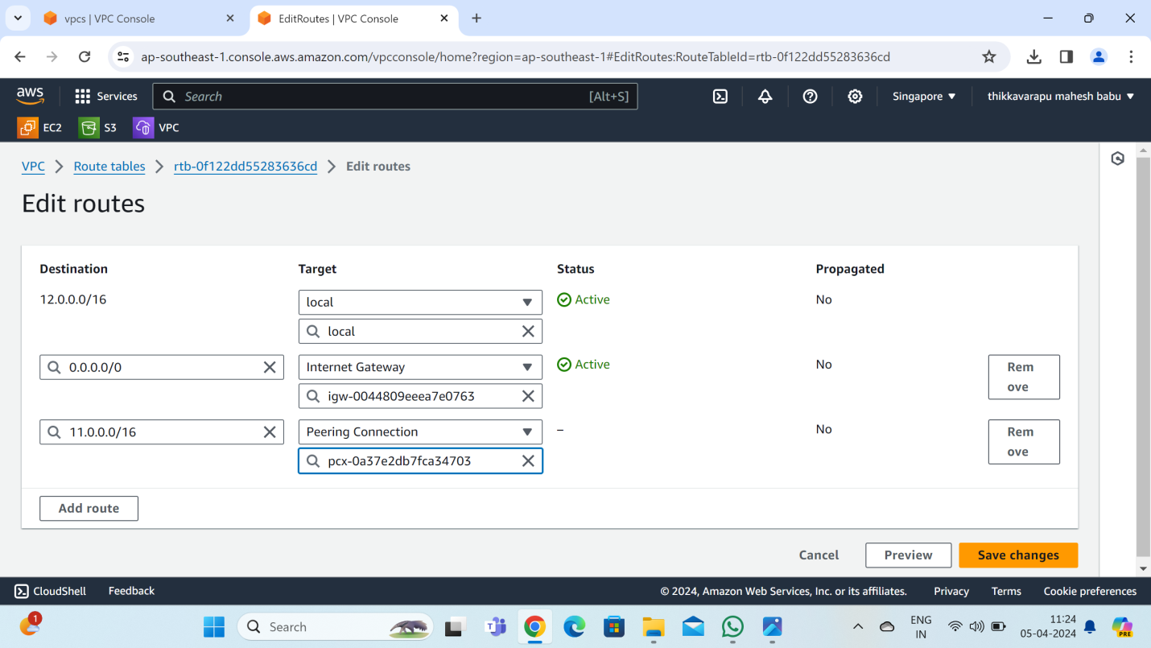

**Go with route table :**

**Edit routs:**

**Add route:**

**Destination: cross region Singapore:ipv4:12.0.0.0/16**

**Target: peering conection**

**“save changes”**

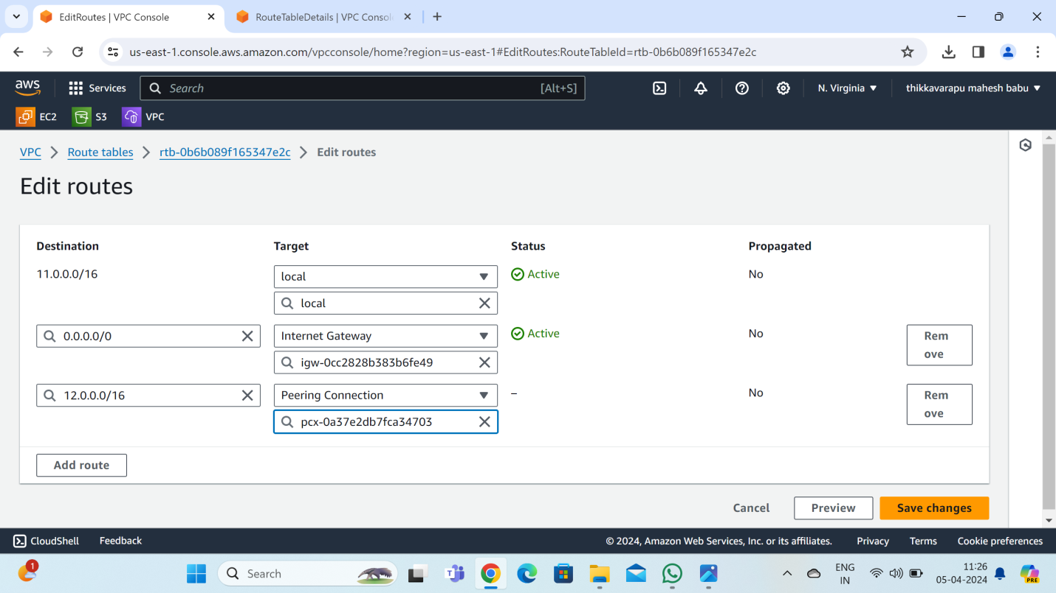

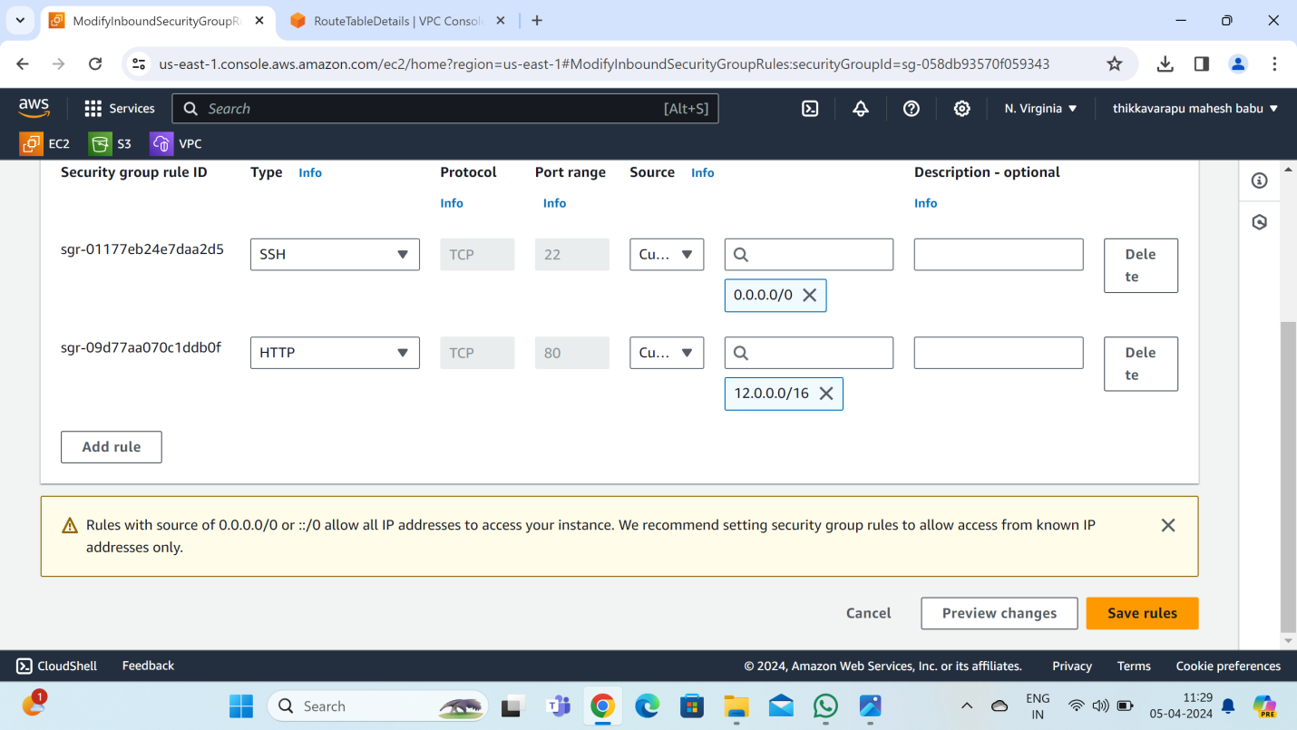

**Open n.virginia EC2 instance:**

**Edit security group rule ID: ADD rule:**

**Type: HTTP , source: cross region :Singapore:ipv4: 12.0.0.0/16**

**“Save rules”**



**Open Singapore EC2 instance :**

**Edit security group rule ID: ADD rule:**

**Type: HTTP, source: cross region :n.virginia:ipv4: 11.0.0.0/16**

**“save rules”**

**Connect to the server in Singapore:**

**Once login to the server**

**Sudo –i**

**Yum update –y**

**Yum install nginx –y**

**Cd /usr/share/nginx/html**

**Ls**

**Rm index.html**

**Permission: ‘yes’**

**Vi index.html**

**Add the data and save**

**Systemctl restart nginx**

**Curl privateips:80 ----enter to see the data**

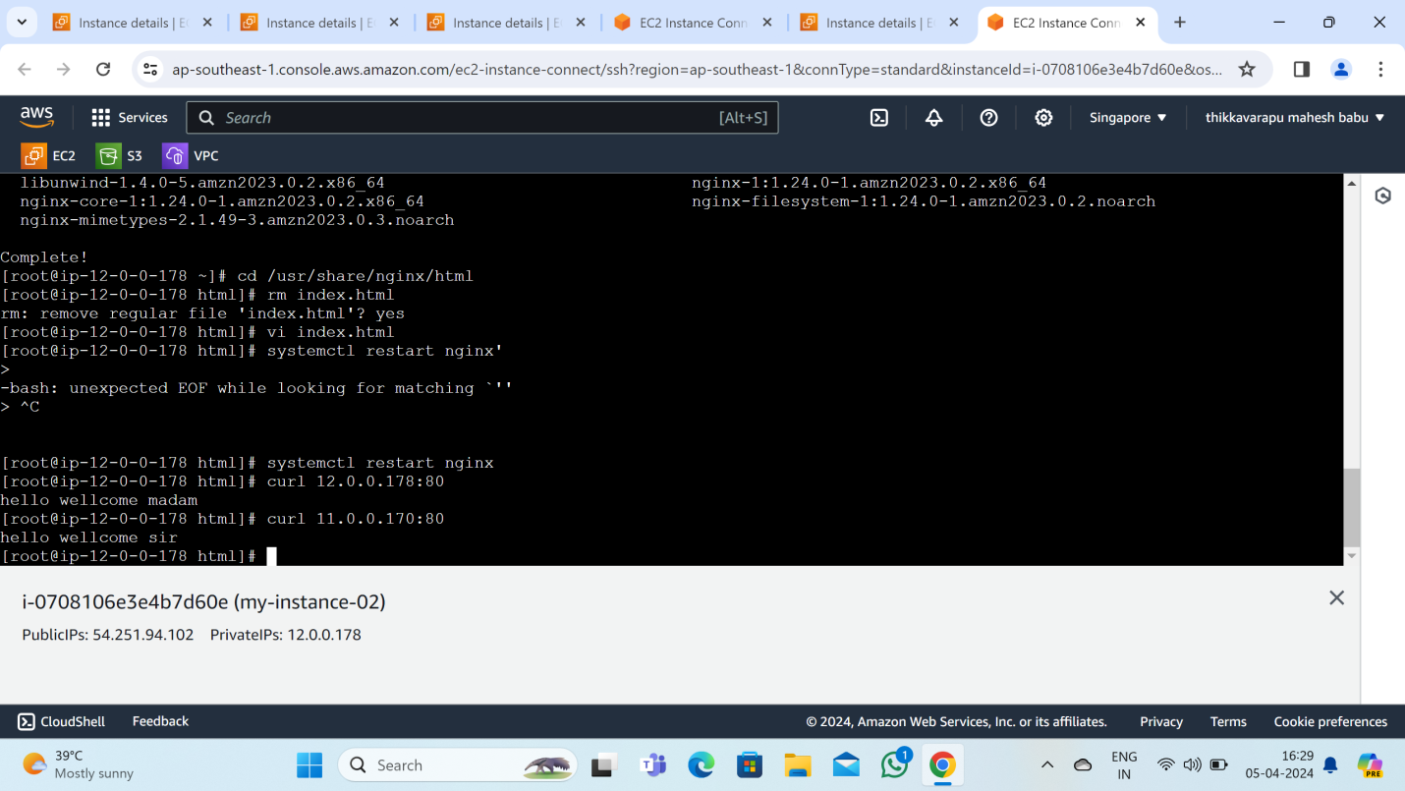

**Publicips:80 to launch chome or browser to see the data**

**Same prosses :**

**Open N.virginia EC2 instance :**

**Edit security group rule ID: ADD rule:**

**Type: HTTP, source: cross region :singapore:ipv4: 12.0.0.0/16**

**“save rules”**

**Connect to the server in N.virginia:**

**Once login to the server**

**Sudo –i**

**Yum update –y**

**Yum install nginx –y**

**Cd /usr/share/nginx/html**

**Ls**

**Rm index.html**

**Permission: ‘yes’**

**Vi index.html**

**Add the data and save**

**Systemctl restart nginx**

**Curl privateips:80 ----enter to see the data**

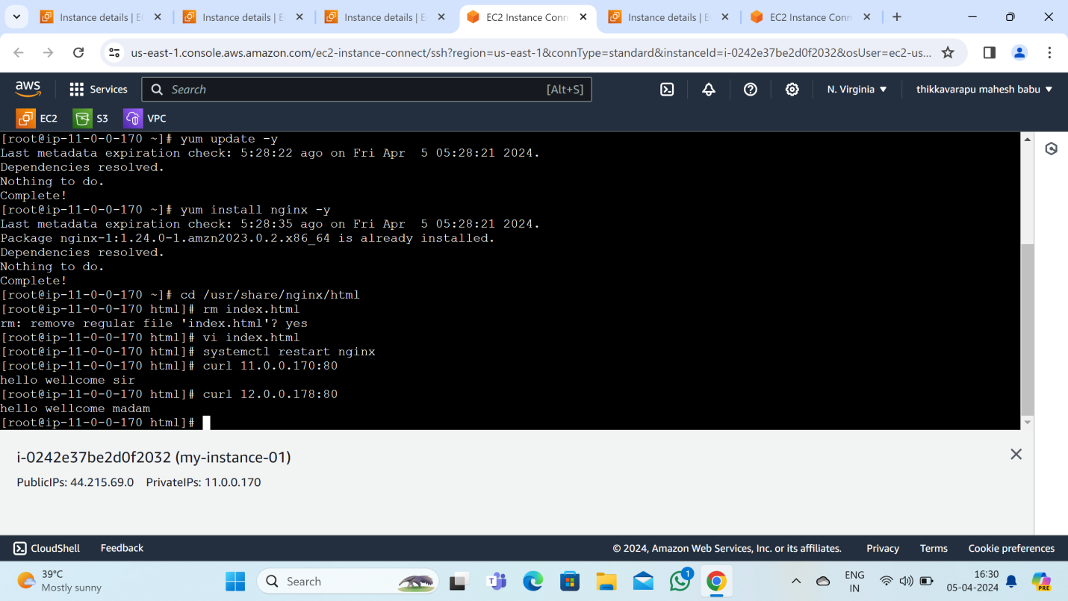

**Publicips:80 to launch chome or browser to see the data**

**Once the process is done to check the data in cross region**

**Singapore data in n.virginia and n.virginia data in Singapore you can see it**

Thus the peering connection is established between 2 VPC’s in different region.